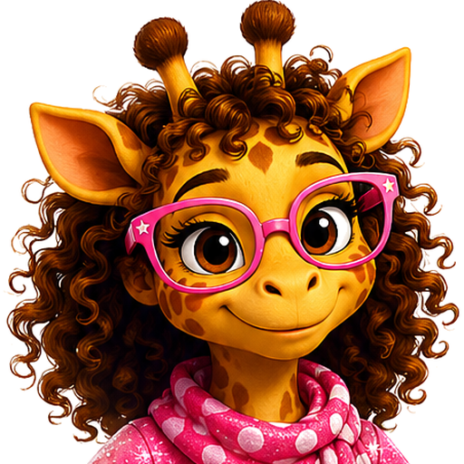 | JoJo Stands Tall  Library Purchase Request Letter Template

Date: ________________________________________________

Library Name: _________________________________________
Attention / Department: _________________________________
Library Address: _______________________________________
City, State, ZIP: _______________________________________
Subject: Request to Add the JoJo Stands Tall Children’s Book Series
Dear Librarian or Collection Development Team,
I am writing to request that the library consider adding the JoJo Stands Tall children’s book series by author Christina Pudetti to its collection.
The series follows JoJo, a small giraffe with pink glasses and a brave heart, as she learns about courage, friendship, belonging, communication, confidence, and standing tall from the inside. The stories are written for children, families, classrooms, and young readers who benefit from books that celebrate differences and self-worth.
Suggested titles include:
- JoJo Stands Tall
- JoJo Finds Her Herd
- JoJo Finds Her Game
- JoJo The Early Years
Additional information about the books, reading order, themes, and author is available at https://jojogiraffe.com/books/.
Thank you for considering this request and for supporting children’s literature that encourages courage, kindness, communication, friendship, and belonging.
Sincerely,
Name: _______________________________________________
Library Card Number (optional): __________________________
Email or Phone (optional): ______________________________
JoJo Stands Tall Series | jojogiraffe.com | Christina Pudetti

